Telephone socket
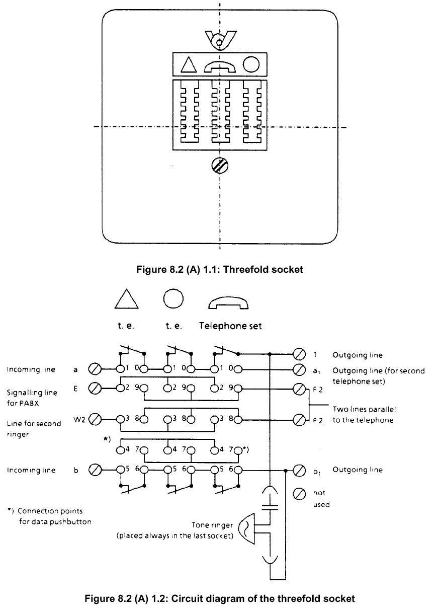
Triangle:
Modem (ADSL)
Circle:
Automatic answering machine
Handset:
Telephone set

Original telephone sockets have a tone ringer inside signaling an incoming call when no telephone is plugged in
See: http://motorang.com/sonstiges/PIC/telefondose.pdf

Circuit diagram Plain Old Telephone Sets
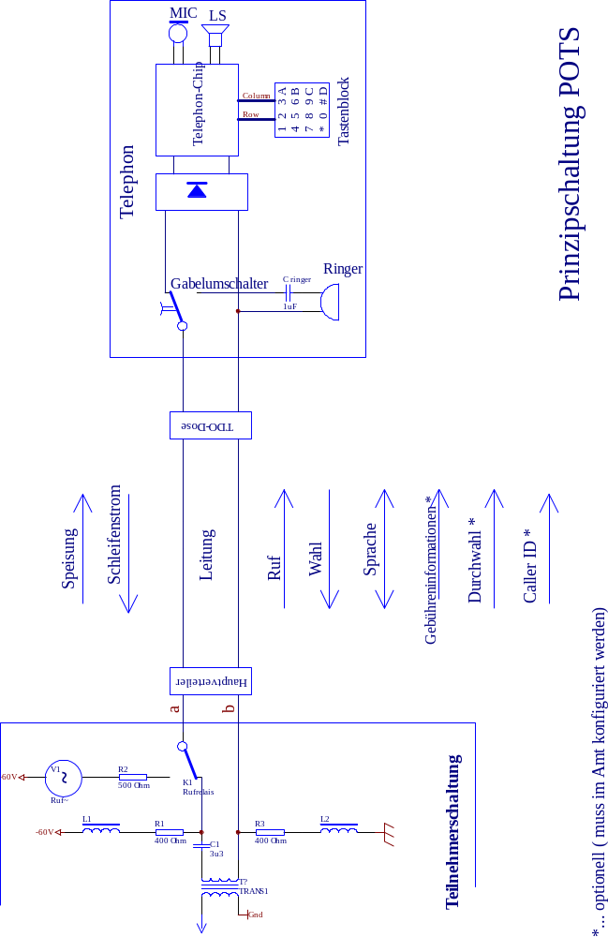
Signals on the telephone line
For long time telecommunications was a monopoly of the national states. For this reason the technical standards for the signals to use on the telephone line are different in every country! European Union tried to harmonize the telephone standards (ETSI-Standard ETS 300 001) but the harmonization is only a harmonization of measurement methods and a list of the different parameters to use in the different countries. It is not possible to export a telephone fabricated for Austria to any other European country without technical modifications!
1. Power supply
Supply voltage: 60V (public network) (private networks: 48V or 24V)
supply current: depending on the line length 19 to 60mA
2. Loop current
The supply current of the telephone is called loop current and signals following conditions:
- Off-Hook flow of loop current
- On-Hook no loop current
- Pulse dialing:
Dialed numbers are signaled as interruption of the loop current.
A one is one interruption, a nine is nine interruptions and a zero is ten interruptions.
The length of the loop current interruption is 60ms wit a pause of 40ms loop current. Between two digits an inter-digit-pause of 850ms is made.
- Modern telephones with DTMF-dialing have a R-Button named Register Recall (Flash):
Pressing this button generates a loop current interruption of 100ms.
This signals the wish of the user to initiate a second conversation. (inquiry call, call transfer or conference call) The first conversation partner is put on hold during inquiry call time.
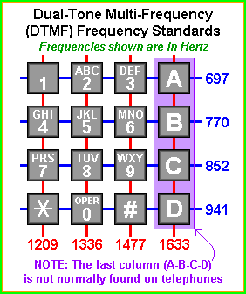
Resistance of the telephone set:
On hook: > 5 MΩ
Off hook: < 500Ω (measured at 19 to 60mA)
3. Ringing
Ring voltage: 25 to 60V~ depending on line length)
Ring frequency: 50Hz (in other countries often 25Hz)
4. DTMF-Dialing
DTMF uses two frequencies to transfer the dialed digit. A row and a column frequency are transferred simultaneously.
levels
Low freq group: -8dBm +-2dB
high freq group -6dBm +-2dB
5. Charging information
Some telephone subscribers want a display of telephone costs. The charging information is an option and transferred by 12 kHz pulses on the telephone line.
The charging pulse receiver at the user’s site has a 12 kHz band stop filter to prevent disturbance of the conversation by charge pulses
6. Speech
Speech signal is transferred line simultaneously in both directions on the telephone.
In the telephone these two signals are separated by a hybrid circuit.
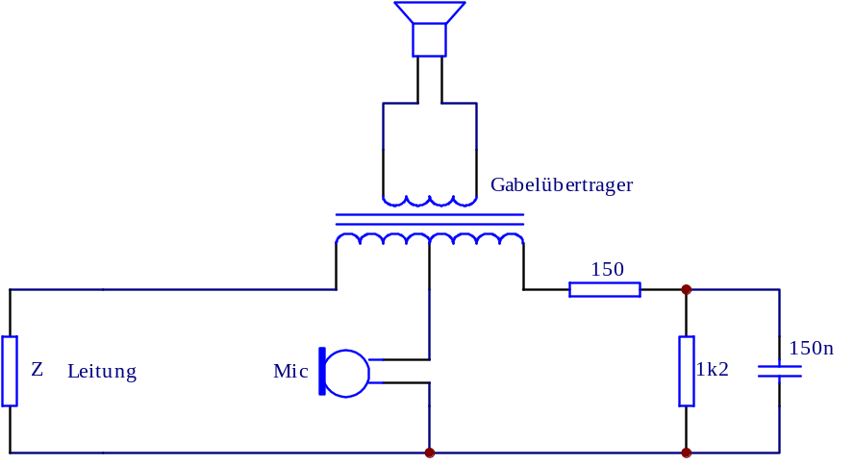
The hybrid circuit should prevent the own sent signals (from the microphone) to come out to the earphone.
It is made by use of a balance network that has nearly the same impedance as the telephone line.
The hybrid is not perfect but it has an attenuation of about 15 dB for own signals that is enough to have about same loudness of distant signal and own signal. Without the hybrid the own sent signal would be much louder than that of the distant conversation partner
In modern telephones the hybrid is an electronic circuit integrated in the telephone chip.
Impedance:
The AC-Impedance at speech frequencies (300 Hz – 3,4 kHz) is 600Ω
Levels:
The average speech level on a telephone line during conversation is –10dBm.
The maximum level in Austria is limited to 2V (in most countries +3dBm)
7. ADSL:
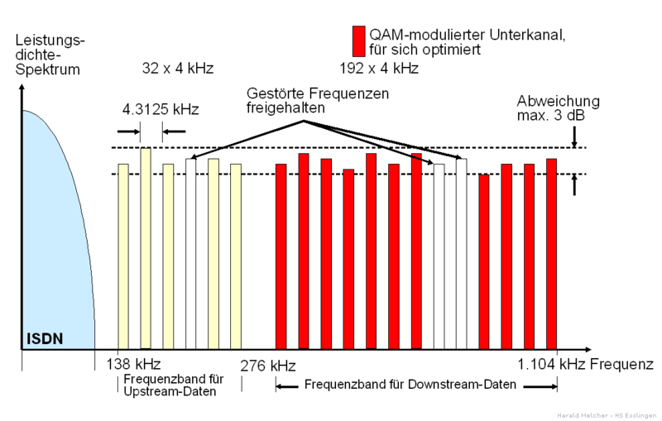
ADSL uses the frequency spectrum above the POTS (or ISDN) signals.
Measurement exercise:
Measure and record all signals on the telephone line during telephone calls and conversations

Measure all signals on the telephone lines using an oscilloscope.
Mind using the correct coupling-method (AC or DC ) for each measurement
Use FFT to show dialed numbers when DTMF is used
Measure signal voltages of both lines in respect to ground
Calculate the voltage between the two lines

Following questions have to be answered:
- Feeding voltage?
- Off-hook voltage?
- Length of dial pulses using pulse- and DTMF-dialing?
- Ring voltage and frequency?
- DTMF Levels and frequencies
- Speech voltage level?
- Length of a Flash-Pulse?
- Bandwidth of the speech signal? (use FFT)

Protocol and interpret all measurements

